The Wittenberg Saturday Science Program
Presents:
“That’s just wrong!”
Moral knowledge from the head, heart, and gut
With Dr. Don Reed

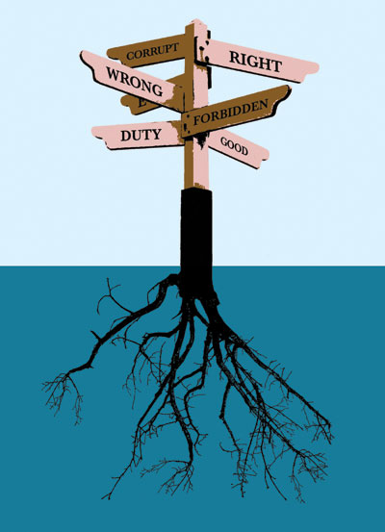
http://neuroanthropology.files.wordpress.com/2010/07/edge-morality.jpg

Morality seems to some just a matter of opinion. Or maybe there are genuine moral rules, but children in different cultures learn different rules, about for instance what should not be eaten. Scientific investigations of moral judgments and of moral impulses and emotions have revealed universal patterns that arose in human evolution. They have also uncovered interesting facts about the relations between conscious judgments and pre-conscious impulses that challenge common notions about how we know right from wrong. After a brief overview of what is known, we will explore one such challenge.

Saturday, November 19, 2011
10:00 a.m. - 12:00 noon
Bayley Auditorium
Barbara Deer Kuss Science Center
Wittenberg University

Please register at http://www.wittenberg.edu/science-outreach.
Directions and more information can be found on the website.

