Evolution and human health: the red queen hypothesis

Darwin suggested that populations change over generations often in response to environmental conditions. Although Darwin’s idea was formulated without an understanding of germ theory or genetics, the application of natural selection to the medical field has seen increased attention as many pathogens are developing resistance. In the lecture portion, we will briefly examine evolution in light of germ theory and discuss the myriad of human health implications. We will discuss the selective pressures both on humans and their pathogens as well as discuss their relative ability to respond to respond to one another (the red queen hypothesis). In the laboratory selection, we will conduct computer simulations meant to examine selective pressures.

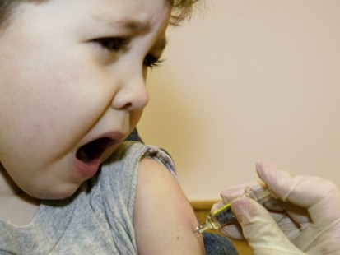

November 10, 2012
10-12:00 noon
Wittenberg University
Barbara Deer Kuss Science Center

http://www.wittenberg.edu/science-outreach

