FIT – Classroom Breakout Group
Erin Hill, Ruth Hoff, Doug Lehman, Debbie Loveless, Lindsay Meermans, Jenna Unterseher
_________________________________________________________________________________________________

This group was tasked with converting existing classrooms into Covid-ready rooms to allow for safe social distancing of 6 ft between each student and the faculty member. As a consequence, many seats were eliminated and moved to other academic buildings or storage, thus reducing the maximum seating capacity of each room.

- As a first step, each desk, table, and chair was labeled according to its current academic building & classroom location. The Registrar’s office will maintain an inventory documentation of each room.

- Each room has been taped out to show where the seating can go (while maintaining the 6 ft distance), and then furniture moved in place. In the coming days, volunteers will be replacing the original painter’s tape with gaffer’s tape.

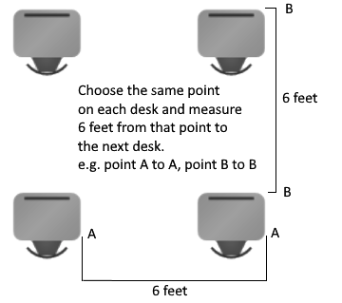

- Any extra furniture has been moved to a centralized room on each floor.

- Volunteers assisted with the above tasks. An announcement will go out to faculty to provide an opportunity to check classrooms before the start of the semester. We ask that you send any issues to a member of this team before moving any classroom furniture around so that we can coordinate with the Registrar’s office.

- Extra classroom furniture has been moved to other buildings and/or storage as needed. All hallway furniture will be taped off with caution tape to stop students from sitting or congregating in the hallways.

- In addition, all academic buildings are being labeled and taped with directional arrows for doorways and staircases and reminders to mask up and to keep your distance, etc.

Considerations for Faculty

Classroom layouts: You’ll notice there will be less room for faculty to move around the room. This is intentional to maintain the 6 ft distance. Please refrain from moving desks, tables, and chairs from their initial positions because these have been spaced out to keep students 6 ft apart.

If your classroom is unable to hold your roster size, there are a number of flexible options available to ensure you are still able to meet face-to-face with your students, in a slightly modified way.

- Hybrid Model - an approach that gives students and the university a great deal of flexibility. Students would complete common asynchronous online activities such as prerecorded lecture sessions, Moodle discussion threads, or other group or individual projects. All on-campus computers have Open Broadcaster software to allow for prerecording of lectures (and also live streaming if needed). Faculty would meet with small groups of students in each session that would allow for social distancing to be employed. The time for face-to-face interaction could be divided equally among the students during the set class meeting times to go over problems, answer questions over the material, have discussions or debates, etc.

- The HyFlex Model - courses would be taught both face-to-face and online by the same instructor at the same time. When students are able to attend, they would be divided into appropriately sized groups to maintain physical distancing. However, if they were unable to attend on their assigned days, they would be able to complete all work online either asynchronously or synchronously. To do it well could require real-time in-class help, an intentionally designed classroom and a great deal of patience from both the students and faculty. Most of our classrooms have limited capabilities for direct video conferencing. We are working with IT on various options and more information will be forthcoming from the IT group.

- A combination of other creative and flexible models exist. Please share all ideas and refer to the Faculty Resources page at WITT: We’re In This Together.

- And remember…

