Retired Faculty
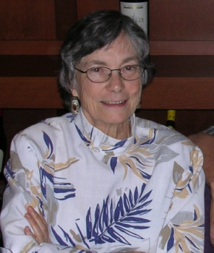 | Dr. Cynthia Behrman cbehrman@wittenberg.edu
 | Dr. Peter Celms
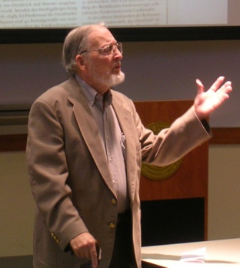 | Dr. Charles Chatfield  echatfield@wittenberg.edu
Dr. Robert Cutler
rcutler@wittenberg.edu

 | Dr. Robert Hartje
 | Dr. Albert Hayden
Dr. James Huffman
jhuffman@wittenberg.edu

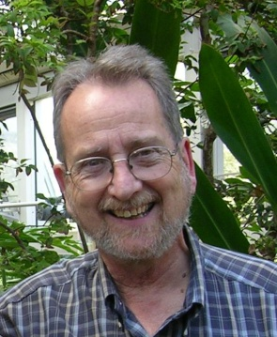 | Dr. Joseph O’Connor  jeoconnor@wittenberg.edu
Dr. Richard Ortquist
rortquist@wittenberg.edu

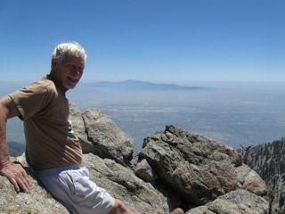 | Dr. Robert Smith  rsmith@wittenberg.edu

Former History Department Faculty
Dr. Nathan Citino- Currently teaching at Colorado State University in Fort Collins, Colorado
Dr. Christopher Oldstone- Moore- Currently teaching at Wright State University in Dayton, Ohio.
Dr. Samuel Thomas- Currently teaching at the University of Alabama in Huntsville, Alabama
Dr. Robin Vose- Currently teaching at St. Thomas University in New Brunswick, Canada

